SIMATS ENGINEERING (SAVEETHA SCHOOL OF ENGINEERING)
Department of Computer Science and Engineering

ASSESSMENT TOOL 1– Concept Mapping

Course Code: | CSA0312 | Course Title: | Data Structures
CO Assessed: | CO1 – Imitation (BL3, BL4) | Assessment: | Assessment Tool 1 – Concept Mapping
Weightage: | 10% of CIA | Total Marks: | 100
CO1 Statement: | Basics, Data, Data object, Data structure, Abstract Data Types (ADT), realization of ADT in ‘C’, Primitive and non-primitive data structure, Linear and non-linear data structure Arrays & Recursion, Performance analysis and Measurement: Time and space analysis of algorithms, Average, best and worst-case analysis.
Student Name: | R.Tamilarasan | Reg. No.: | 192511298
Section / Batch: |  | Date:
Code of Conduct
I R.Tamilarasan(192511298) (Name / Reg No) certify that this submission is my original work and that I have adhered to the guidelines specified for this assessment. I understand that any violation of academic integrity rules will result in disciplinary action.
Signature of the Student:
Instructions
- This test contains 2 concept mapping, Total: 100 Marks.
- Evaluation of Answer Quality -Checking whether the answer includes: Concept Identification , Linkages, Organization, Integration of Literature, and Clarity
- No DTP printouts or electronic devices permitted. They should provide materials in PDF format.

Rubrics

Questions | Problem Understanding | Method Selection | Solution Process | Accuracy of Calculation | Interpretation of Results | Total Marks
Q1
Q2

Annexure A – Concept Mapping

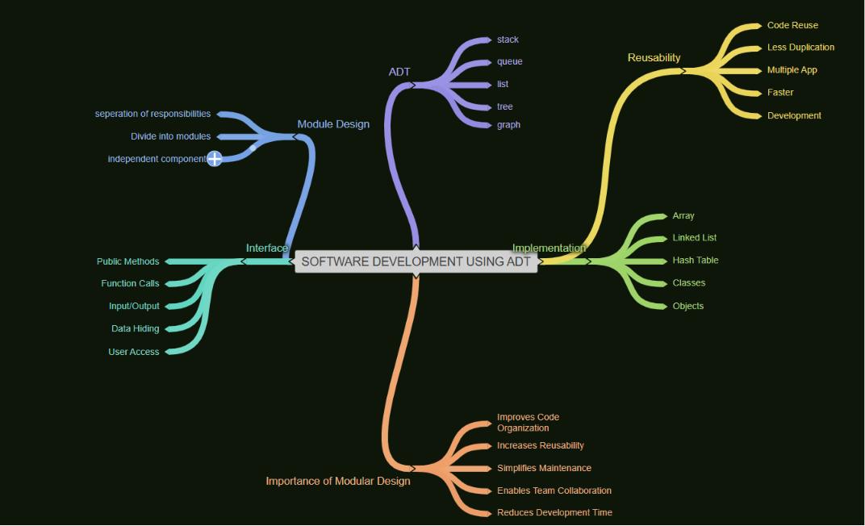
Q4 A ride-sharing application must efficiently match users with nearby drivers in real time. Construct a concept map connecting Algorithm → Input Size → Time Complexity → Space Complexity → Efficiency → Performance Measurement. Illustrate how increasing input size impacts system performance and establish relationships between these concepts. Analyze how the choice of algorithm affects efficienc
Q34. A software development team builds reusable modules for different applications. Construct a concept map connecting ADT → Module Design → Interface → Implementation → Reusability → Maintainability. Explain how modular design improves software development and justify its importance.
